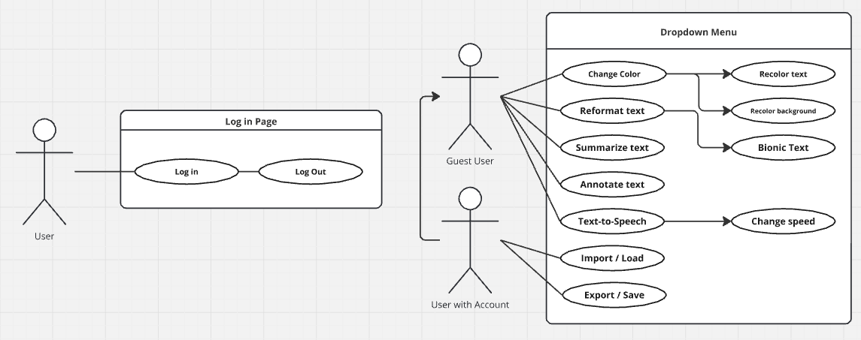

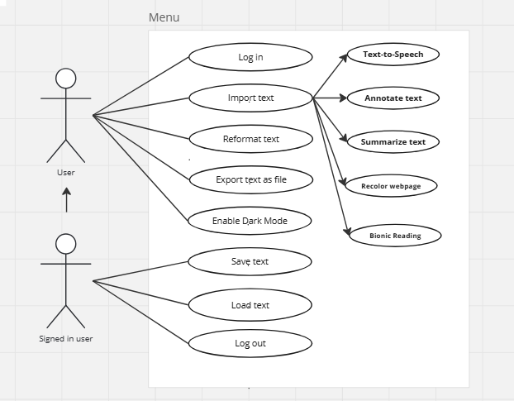

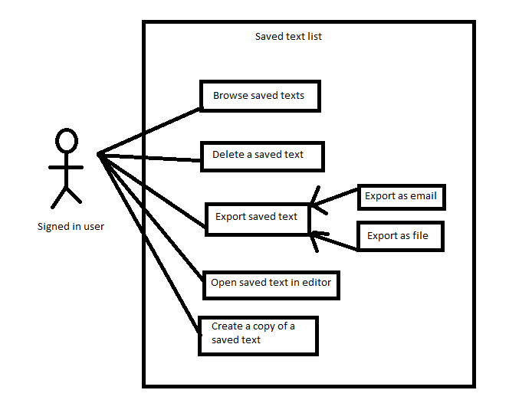

| **Name/Title:** | Bionic Text |
| --- | --- |
| **ID:** | 1 |
| **Description**: | ComfortRead shall have an option to let the user reformat the text for **bio**nic **rea**ding. |
| **System Under Design:** | ComfortRead |
| **Primary Actor**: | User |
| **Participants**: | None |
| **Goal**: | Allow a user to bold the first half of each word without manually highlighting every word |
| **Precondition**: | User has text pasted in |
| **Success Postcondition**: | First half of every word is bolded |

| **USER STEPS**:  1. User clicks 3 line button  3. User clicks Format box  5. User clicks Bionic Text checkbox | **SYSTEM RESPONSE**:  2. The options sidebar is displayed  4. Format dropdown is displayed  6. Every first half of each word is bolded. (Only highlighted words if any are highlighted) |
| --- | --- |

| **Name/Title:** | Discover Presets |
| --- | --- |
| **ID:** | 2 |
| **Description**: | ComfortRead shall have an experiment option that cycles preset formats for users unsure of what reading style is most comfortable for them. |
| **System Under Design:** | ComfortRead |
| **Primary Actor**: | User |
| **Participants**: | None |
| **Goal**: | Allow a user to discover a reading style by choosing between presets |
| **Precondition**: | User has text pasted in |
| **Success Postcondition**: | Preset is chosen and formats based on user choice |

| **USER STEPS**:  1. User clicks 3 line button  3. User clicks Preset box  5. User clicks ComfortRead dropdown  7. User clicks on a preset | **SYSTEM RESPONSE**:  2. The options sidebar is displayed  4. Preset dropdown is displayed  6. All pre-made presets are displayed  8. App formats to presets pre-made settings (ex. Simple Bionic sets font to Sato Sans and bolds first half of every word) |
| --- | --- |

| **Name/Title:** | Change Reader Voice |
| --- | --- |
| **ID:** | 3 |
| **Description**: | ComfortRead shall have an option for text to speech that can be set to different reading voices. |
| **System Under Design:** | ComfortRead |
| **Primary Actor**: | User |
| **Participants**: | None |
| **Goal**: | Allow a user to choose how to listen to the text read by the computer |
| **Precondition**: | User has text pasted in |
| **Success Postcondition**: | Text to speech will read at desired speed |

| **USER STEPS**:  1. User clicks 3 line button  3. User clicks Extra box  5. User clicks Voice dropdown  7. User clicks Voice option | **SYSTEM RESPONSE**:  2. The options sidebar is displayed  4. Extra dropdown is displayed  6. Voice options are displayed  8. Text to speech will now read with selected voice |
| --- | --- |

| **Name/Title:** | Change Color |
| --- | --- |
| **ID:** | 4 |
| **Description**: | ComfortRead shall let the user choose custom text and background color options. |
| **System Under Design:** | ComfortRead |
| **Primary Actor**: | User |
| **Participants**: | None |
| **Goal**: | Allow a user to change background and text color |
| **Precondition**: | User has text pasted in |
| **Success Postcondition**: | Text and/or background color is changed |

| **USER STEPS**:  1. User clicks 3 line button  3. User clicks Color box  5. User clicks Background or Text box  7. User types Hex code | **SYSTEM RESPONSE**:  2. The options sidebar is displayed  4. Preset dropdown is displayed  6. System waits for input  8. Selected setting is updated to given hex value; color updates |
| --- | --- |

| **Name/Title:** | Enable dark mode |
| --- | --- |
| **ID:** | 5 |
| **Description**: | Allows the user to enable dark mode feature. |
| **System Under Design:** | ComfortRead |
| **Primary Actor**: | User |
| **Participants**: | None |
| **Goal**: | Allows a user to enable dark mode feature. |
| **Precondition**: | User has opened the application |
| **Success Postcondition**: | Dark Mode is enabled |

| **USER STEPS**:  1. User clicks 3 bar icon  3. User clicks “Presets” option  5. User clicks the Dark Mode checkbox | **SYSTEM RESPONSE**:  2. The options sidebar is displayed  4. The presets dropdown is displayed  6. The color of elements on the application are replaced with a darker color, and the color of text is replaced with a lighter color, and the dark mode checkbox toggles. |
| --- | --- |

| **Name/Title:** | Reformat text |
| --- | --- |
| **ID:** | 6 |
| **Description**: | User can take any text written or pasted in the box and reformat it to their liking |
| **Primary Actor**: | Reader |
| **Goal**: | To help aid reader’s comprehension of the text |
| **Precondition:** | Options dropdown menu must already be down.  Text must already be copied in. |
| **Related Use Cases**: | Extension: UC-5 Reformat text |

| **USER STEPS**:  1. User clicks “Format” under options dropdown menu  3. User clicks “Bionic Text” checkbox  5. User clicks a “Spacing” box  7. User inputs a number in selected box | **SYSTEM RESPONSE**:  2. System expands all formatting options  4. System bolds the first half of every word in the document  6: System waits for user to put in a number  8: System changes the spacing to user’s input number value |
| --- | --- |

| **Name/Title:** | Import text from a file |
| --- | --- |
| **ID:** | 7 |
| **Description**: | ComfortRead shall have a feature that allows users to import text from a HTML or text document |
| **System Under Design:** | ComfortRead |
| **Primary Actor**: | User |
| **Participants**: | None |
| **Goal**: | Import text from a file and display it in the application |
| **Related Use Cases**: | REQ-6: ComfortRead shall have an option for users to paste text, or import it from a text document. |
| **Precondition**: | Options dropdown menu must already be down.  User must be logged in. |
| **Success Postcondition**: | The file contents are displayed in the application |

| **USER STEPS**:  1. User opens sidebar by clicking 3 bar icon  3. User clicks “Import/Export” button  5. User clicks “Import text file”  7. User clicks on the saved text file | **SYSTEM RESPONSE**:  2. “Import/Export” button is displayed on sidebar  4. “Import text file” button is displayed  6. File dialog is displayed  8. If the file has a valid extension, and correct formatting, the text is displayed in the application. Otherwise, a warning message is shown. |
| --- | --- |

| **Name/Title:** | Export as HTML file |
| --- | --- |
| **ID:** | 8 |
| **Description**: | ComfortRead shall have a feature that allows users to export formatted text as an HTML file. |
| **System Under Design:** | ComfortRead |
| **Primary Actor**: | User |
| **Participants**: | None |
| **Goal**: | Export text as HTML file |
| **Related Use Cases**: | REQ-8: ComfortRead shall have a feature that allows users to export formatted text as an HTML file. |
| **Precondition**: | User has entered text.  User is logged in. |
| **Success Postcondition**: | The HTML file was downloaded to the users device |

| **USER STEPS**:  1. User opens sidebar by clicking 3 bar icon  3. User clicks “Import/Export” button  5. User clicks “Export text file” | **SYSTEM RESPONSE**:  2. “Import/Export” button is displayed on sidebar  4. “Export text file” button is displayed  6. File is saved on users device |
| --- | --- |

| **Name/Title:** | Change Font Size |
| --- | --- |
| **ID:** | 9 |
| **Description**: | ComfortRead shall have a feature that allows users to adjust the font size of the input text. |
| **System Under Design:** | ComfortRead |
| **Primary Actor**: | User |
| **Participants**: | None |
| **Goal**: | Allow users to change the font of text to any size of their liking. |
| **Related Use Cases**: | REQ-5: ComfortRead shall have an option to let users save their formatting preferences. |
| **Precondition**: | 1. User has pasted text into textbox 2. User has opened “Format” menu |
| **Success Postcondition**: | 1. Text font size selected by user has been changed |

| **USER STEPS**:  1. User pastes text into textbox  3. User clicks “Format” button  5. User clicks on “Font Size” input field  7. User enters font size | **SYSTEM RESPONSE**:  2. Text is displayed  4. Format menu is displayed on screen  6. System waits for user input  8. Font size is updated |
| --- | --- |

| **Name/Title:** | Bookmark/label section of text |
| --- | --- |
| **ID:** | 10 |
| **Description**: | ComfortRead shall have a feature that allows users to bookmark a paragraph or section of text |
| **System Under Design:** | ComfortRead |
| **Primary Actor**: | User |
| **Participants**: | None |
| **Goal**: | Allow user to bookmark section of text |
| **Precondition**: | User has entered text |
| **Success Postcondition**: | Section of text has visible bookmarked icon next to it |

| **USER STEPS**:  1. User right clicks to open context menu  3. User clicks create bookmark button | **SYSTEM RESPONSE**:  2. Button with a bookmark icon is displayed.  4. Bookmark icon is displayed next to the section of text |
| --- | --- |

| **Name/Title:** | Change Font Style |
| --- | --- |
| **ID:** | 11 |
| **Description**: | ComfortRead shall have a feature that allows users to adjust the font style of the input text. |
| **System Under Design:** | ComfortRead |
| **Primary Actor**: | User |
| **Participants**: | None |
| **Goal**: | Allow users to change the font of text to any style of their liking. |
| **Related Use Cases**: | REQ-5: ComfortRead shall have an option to let users save their formatting preferences. |
| **Precondition**: | User has pasted text into textbox  User has opened “Format” menu |
| **Success Postcondition**: | 1. Text font style selected by user has been changed |

| **USER STEPS**:  1. User pastes text into textbox  3. User clicks “Format” button  5. User clicks “Font style” button  7. User clicks on a font style | **SYSTEM RESPONSE**:  2. Text is displayed  4. Format menu is displayed on screen  6. Font styles are displayed in a dropdown  8. Font style is updated |
| --- | --- |

| **Name/Title:** | Change Line Spacing |
| --- | --- |
| **ID:** | 12 |
| **Description**: | ComfortRead shall have a feature that allows users to adjust the line spacing of the input text. |
| **System Under Design:** | ComfortRead |
| **Primary Actor**: | User |
| **Participants**: | None |
| **Goal**: | Allow users to change the line spacing to any size of their liking. |
| **Related Use Cases**: | REQ-5: ComfortRead shall have an option to let users save their formatting preferences. |
| **Precondition**: | User has pasted text into textbox  User has opened options dropdown menu |
| **Success Postcondition**: | Text line spacing has been changed. |

| **USER STEPS**:  1. User clicks “Format” button  3. User clicks a spacing input field  5. User inputs desired spacing | **SYSTEM RESPONSE**:  2. Format menu is displayed on screen  4. System waits for input  6. System updates text spacing |
| --- | --- |

| **Name/Title:** | Text-to-speech |
| --- | --- |
| **ID:** | 13 |
| **Description**: | ComfortRead shall have an option for text to speech that can be set to different reading voices. |
| **System Under Design:** | ComfortRead |
| **Primary Actor**: | User |
| **Participants**: | None |
| **Goal**: | Allow users to utilize text to speech to read text. |
| **Related Use Cases**: | Change Reader Speed |
| **Precondition**: | User has pasted in text  User has selected text to speech set up options |
| **Success Postcondition**: | Text is read to user at desired speed |

| **USER STEPS**:  1. User clicks “Extra” option  3. User clicks “Speed” dropdown  5. User clicks on desired speed  7. User clicks speaker symbol at the top right | **SYSTEM RESPONSE**:  2. Extra option menu displayed on screen  4. Speed settings are displayed  6. TTS reading speed is saved  8. TTS reads at desired speed |
| --- | --- |

| **Name/Title:** | Annotate Text |
| --- | --- |
| **ID:** | 14 |
| **Description**: | ComfortRead shall allow a logged-in users to add annotations (such as highlights or comments) to the text in a document they are reading or editing. |
| **System Under Design:** | ComfortRead |
| **Primary Actor**: | User |
| **Participants**: | None |
| **Goal**: | Add Annotations to a document |
| **Related Use Cases**: | Reformat Text |
| **Precondition**: | User has uploaded a document or selected a document to read/edit |
| **Success Postcondition**: | The document contains the user’s annotations which are temporarily saved in the current session. |

| **USER STEPS**:  1. User highlights text  3. User clicks “Annotate” option on toolbar  5. User types in text in textbox  7. User clicks annotation | **SYSTEM RESPONSE**:  2. Highlight toolbar is displayed  4. A textbox pointing at the highlighted text is displayed, system waits for input  6. System saves annotation  8. Annotation pops up for user to read |
| --- | --- |

| **Name/Title:** | Focus Mode |
| --- | --- |
| **ID:** | 15 |
| **Description**: | ComfortRead shall have a feature that allows logged-in users to enable a “Focus Mode”, which hides all background elements, menus, and non-essential information in order to create a distraction-free reading environment. |
| **System Under Design:** | ComfortRead |
| **Primary Actor**: | User |
| **Participants**: | None |
| **Goal**: | Hide all non-essential information |
| **Related Use Cases**: | Reformat Text  Customize Preferences |
| **Precondition**: | None |
| **Success Postcondition**: | Focus Mode is enabled and all non-essential user interface elements (toolbars, menus, background) are hidden for enhanced user focus. |

| **USER STEPS**:  1. User clicks eye symbol in the top left of the text page while UI is visible  3. User clicks eye symbol in the top left of the text page while UI is invisible | **SYSTEM RESPONSE**:  2. System hides all background UI elements displaying only the text provided, the eye symbol, and the text-to-speech symbol.  4. All previously displayed UI elements reappear |
| --- | --- |

| **Name/Title:** | Deleting a saved text |
| --- | --- |
| **ID:** | 16 |
| **Description**: | When browsing their saved texts, a signed in user can tell ComfortRead to delete one of their saved texts. After confirming the action, ComfortRead will delete the saved text. |
| **Related Use Cases**: | Browse saved texts |
| **System Under Design:** | ComfortRead |
| **Primary Actor**: | User |
| **Precondition**: | User is signed in  User has at least one saved text |
| **Success Postcondition**: | The text selected for deletion is no longer in the user’s saved text list  Non selected texts are still in the user’s saved text list |

| **USER STEPS**:  1. Select “Files”  3. Click “View Files”  5. Checks a box next to the saved text they are deleting  7. User selects “Delete” option  9. User confirms their intent to delete the selected text | **SYSTEM RESPONSE**:  2. Displays files menu  4. Displays all saved files  6. System stores file info for later input  8. Displays prompt asking user to confirm action  10. System removes that text from the user’s saved text list |
| --- | --- |

| **Name/Title:** | Copy a saved text |
| --- | --- |
| **ID:** | 17 |
| **Description**: | A signed in user can navigate to a page to view a list of their saved texts |
| **System Under Design:** | ComfortRead |
| **Primary Actor**: | User |
| **Related Use Cases**: | Delete a saved text  Export saved text  Open saved text in editor  Create a copy of a saved text |
| **Precondition**: | User is signed in  User has at least one saved text |
| **Success Postcondition**: | A list of the user’s saved texts is displayed |

| **USER STEPS**:  1. Select “Files”  3. Click “View Files”  5. Checks a box next to the saved text they are copying  7. User selects “Copy” option  9. User confirms their intent to copy the selected text | **SYSTEM RESPONSE**:  2. Displays files menu  4. Displays all saved files  6. System stores file info for later input  8. Displays prompt asking user to confirm action  10. System copies that text from the user’s saved text list and creates a new duplicate file below it with “(Copy)” added to the end of the file name. |
| --- | --- |

| **Name/Title:** | Summarize text |
| --- | --- |
| **ID:** | 18 |
| **Description**: | When the user has text pasted in, they can get an AI generated summary of the text |
| **System Under Design:** | ComfortRead |
| **Primary Actor**: | User |
| **Related Use Cases**: | Import text |
| **Precondition**: | Options dropdown is displayed |
| **Success Postcondition**: | ComfortRead displays an AI generated summary of the user’s text. The summary has the same text reformatting options applied to it. |

| **USER STEPS**:  1. User selects “Summarize” option | **SYSTEM RESPONSE**:  2. System fetches and displays an AI generated summary of the user’s text at the top of the text file |
| --- | --- |